Active learning is a form of semi-supervised machine learning where the algorithm can choose which data it wants to learn from. With this approach, the program can actively query an authority source, either the programmer or a labeled dataset, to learn the correct prediction for a given problem.

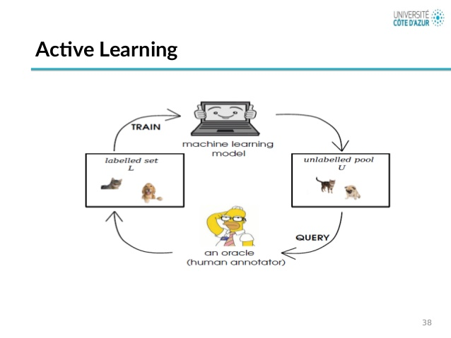

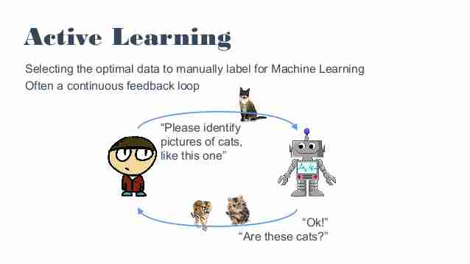

First, a model is trained on the currently labeled pool. Secondly, some measure of information on each individual unlabeled sample is being computed. Thirdly, an acquisition function is applied. A subset of a pre-specified amount of elements maximizing the acquisition function is annotated by an oracle. It is then added to the labeled pool. The process is repeated until either a desired performance or labeling budget is reached.

In a typical AL scenario for image classification problems, a subset of promising images from an unlabeled pool is sampled. Such an acquisition function has been adopted for semantic segmentation in for retrieving images, but based on their accumulated per-pixel information content projecting all the information extracted from an image onto a single value. The paper is proposing to design acquisition to explicitly focus on image regions inside of the entire unlabeled pool of images and further to not only consider information during region selection but also annotation costs.

FCN8s [Fully Convolutional Networks for Semantic Segmentation]